Lab Exercise 4 - Run a High-Throughput Load Test and Diagnose a Simulated Hotspot Using Key Visualizer Heatmaps

1. Lab Overview
In this lab, you will use Google Cloud Bigtable to generate a high-throughput workload and intentionally create a hotspot by using poorly distributed row keys.
You will then use Key Visualizer to analyze the workload and identify the hotspot.
The lab demonstrates an important Bigtable design principle:
Poor row-key design can concentrate traffic on a small portion of the Bigtable keyspace, causing hotspots.
You will first create a table, generate normal traffic, generate hotspot traffic, and finally analyze the workload using Key Visualizer.

2. Learning Objectives
By completing this lab, you will learn how to:
- Create a Bigtable table.
- Create a column family.
- Insert a large number of rows.
- Generate high-throughput writes.
- Understand row-key distribution.
- Simulate a hotspot.
- Use Key Visualizer to analyze Bigtable performance.
- Identify concentrated traffic.
- Understand how salting can reduce hotspots.
- Compare poor and improved row-key designs.

3. Scenario
Imagine an IoT application collecting temperature readings.
A poorly designed application uses row keys such as:
sensor001
sensor002
sensor003
sensor004
...
Suppose most writes are going to:
sensor001
or to a small sequential range:
sensor001
sensor002
sensor003
...
This can concentrate workload in a small section of the Bigtable keyspace.
Conceptually:

Bigtable Keyspace
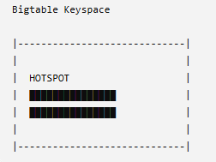
A better design distributes writes across the keyspace.

4. Architecture
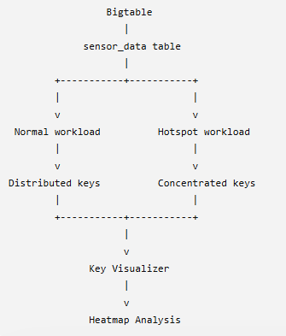

5. Prerequisites
You need:
- Google Cloud project
- Google Cloud Shell
- Google Cloud CLI
- Bigtable instance
- cbt CLI
- Permission to access Bigtable
- Key Visualizer access

6. Set Environment Variables
Set the variables:
export PROJECT_ID=$(gcloud config get-value project)
export INSTANCE_ID="training-bigtable"
export TABLE_ID="hotspot_test"
export COLUMN_FAMILY="metrics"
Verify:
echo $PROJECT_ID
echo $INSTANCE_ID
echo $TABLE_ID
echo $COLUMN_FAMILY

7. Configure the cbt CLI
Configure cbt:
cbt -project=$PROJECT_ID -instance=$INSTANCE_ID ls
You may see:
2026/08/03 ... -creds flag unset, will use gcloud credential
This message is normal when cbt is using your authenticated Google Cloud credentials.
You can also configure a ~/.cbtrc file:
cat > ~/.cbtrc <<EOF
project = $PROJECT_ID
instance = $INSTANCE_ID
EOF
Test:
cbt ls

8. Create the Test Table
Create the table:
cbt createtable $TABLE_ID
Create the column family:
cbt createfamily $TABLE_ID $COLUMN_FAMILY
Verify:
cbt ls
Expected:
hotspot_test
metrics

9. Insert a Test Row
Before generating the large workload, test the table.
cbt set $TABLE_ID sensor001 metrics:temperature=28.5
Read the row:
cbt lookup $TABLE_ID sensor001
Expected:
sensor001
metrics:temperature = 28.5

10. Generate a Normal Workload
First create reasonably distributed row keys.
For example:
sensor000001
sensor000002
sensor000003
...
sensor010000
Generate 10,000 rows:
for i in $(seq -w 1 10000); do
cbt set $TABLE_ID "sensor$i" metrics:temperature=$((20 + RANDOM % 15))
done
This creates rows such as:
sensor00001
sensor00002
sensor00003
...
Check the number of rows:
cbt count $TABLE_ID
You should see approximately:
10000

11. Understand the Normal Workload
The row keys are distributed across a range:
sensor00001
sensor00002
sensor00003
...
sensor09999
sensor10000
The workload is therefore more distributed than repeatedly writing to one row.

Conceptually:
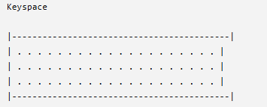

12. Generate a Simulated Hotspot
Now we intentionally create a hotspot.
Instead of distributing writes across thousands of rows, repeatedly write to a small number of rows.
For example:
hotspot001
hotspot002
hotspot003
Run:
for i in $(seq 1 30000); do
ROW=$(printf "hotspot%03d" $((RANDOM % 3 + 1)))
TEMP=$((20 + RANDOM % 15))
cbt set $TABLE_ID $ROW metrics:temperature=$TEMP
done

This repeatedly writes to only:
hotspot001
hotspot002
hotspot003
This is our simulated hotspot.

13. Verify the Hotspot Rows
Read the rows:
cbt lookup $TABLE_ID hotspot001
cbt lookup $TABLE_ID hotspot002
cbt lookup $TABLE_ID hotspot003
You should see the latest temperature values.

14. Generate a Stronger Hotspot
To make the workload more obvious, repeatedly write to a single row:
for i in $(seq 1 50000); do
cbt set $TABLE_ID hotspot001 metrics:temperature=$((20 + RANDOM % 15))
done

Now most of the writes are directed toward:
hotspot001
Conceptually:
Keyspace
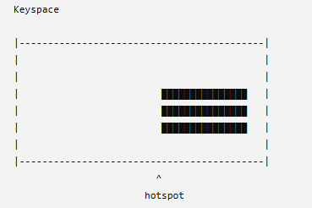

15. Check the Row
Run:
cbt lookup $TABLE_ID hotspot001
You should see the latest value.
If multiple cell versions are configured, older versions may also be visible.

16. Understand Why This Is a Hotspot
Bigtable distributes data and workload across its keyspace.
When applications repeatedly access a small portion of the keyspace, the workload can become concentrated.
Our workload looks like:
Normal:
sensor00001
sensor00002
sensor00003
sensor00004
sensor00005
...
sensor10000
Hotspot:
hotspot001
hotspot001
hotspot001
hotspot001
hotspot001
...
hotspot001
The second pattern creates much more concentrated traffic.

17. Open Key Visualizer
Open the Google Cloud Console.
Navigate to:
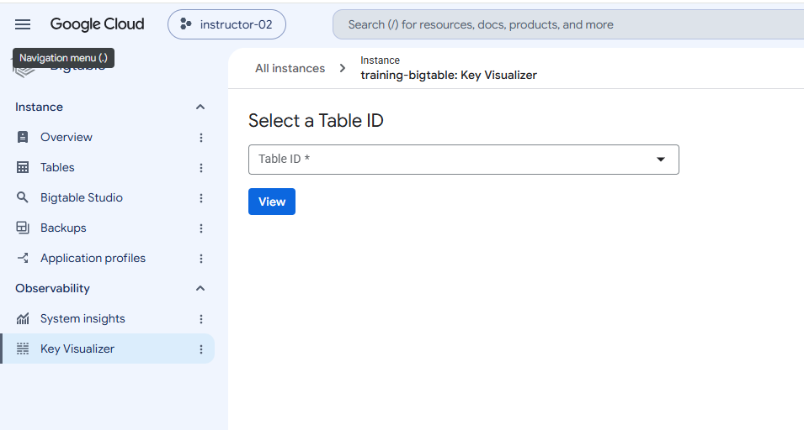
Select the relevant table:
hotspot_test
Key Visualizer provides visual information about Bigtable workload distribution across the keyspace.

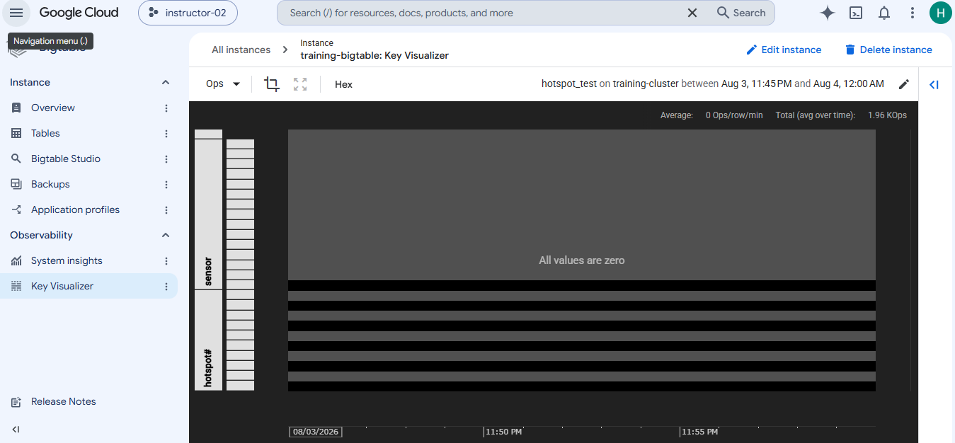

18. Analyze the Heatmap
Look for areas with significantly higher activity.
A conceptual hotspot might look like:
Low activity Low activity High activity
░░░░░░░░░░░░░░░░░░░░░░░░░░░░░░░░████████████
░░░░░░░░░░░░░░░░░░░░░░░░░░░░░░░░████████████
░░░░░░░░░░░░░░░░░░░░░░░░░░░░░░░░████████████
The darker/higher-intensity region indicates a concentration of workload.
Note: Key Visualizer needs sufficient workload and time to collect and display useful visualization data. A very short lab run may not immediately produce an obvious heatmap.

